Travel Mart guide

Service Provider

July/2014 For Internal Distribution Only
Contents
Introduction 2
How to Log In 3
How to change your password 4
Using the Service Provider System 5
Service Provider Homepage 5
View data by Date 6
How to Confirm Manifest 7
How to Cancel Manifest 10
Service Provider Confirmation 13

Introduction

Last updated: July, 2014
Created by: Chiara van der Kwast

Travel Mart is a web based system created and managed by the Shipboard HR Strategy and Services of Royal Caribbean Cruises Ltd. This tool was designed to provide crewmember travel arrangements.
General information such as; E1identifications, names, and passport information will be visible to all users. Other information including; scheduled bookings with transportation vendors, hotel specialists, and the air team is displayed.
Save and print documents or itineraries, follow ongoing procedures by viewing remarks made by users and much more with Travel Mart.
For support or issues with the system, contact SHRSS_Support@rccl.com

How to Log In

Step 1: Go to Https://www.rclcrew.com
Step 2: Enter your Username and Password in the appropriate fields.
Step 3: Click on Log In
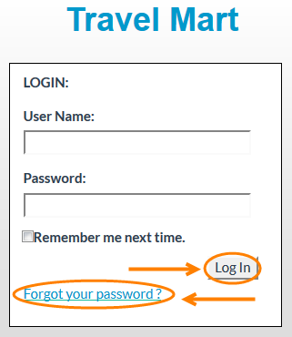
Note: If you are logging in for the first time, enter the username and password provided. Once you have logged in you will be prompted to change your password.
Forgot your password? Click on Forgot your password.
Enter your Username and you will receive and email with your password.
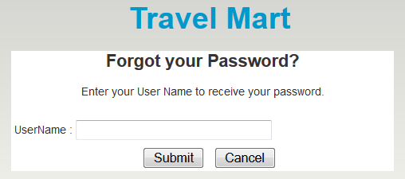

How to change your password

Step 1: At the top right corner of the screen, click on Change Password.
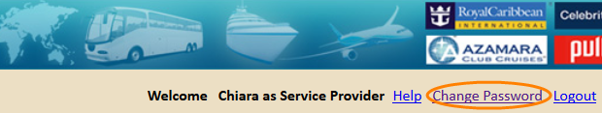
Step 2: In the field Password, enter your current password.
Step 3: In the field New password, enter the new password.
Step 4: Confirm your new password and click on Save.
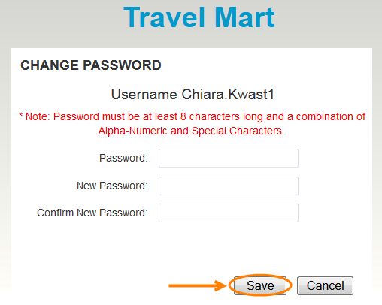

Note: Passwords are case sensitive and must be at least 8 characters long and a combination of Alpha-Numeric and Special Characters.

Using the Service Provider System

Service Provider Homepage
The Dashboard displays a summary of manifest-status count of all Service Provider vendors associated to this user. The default view will show all ports assigned to your account.

Note: The homepage will display information per service such as; Hotel Service or Transportation Service.
Only if you have multiple ports assigned to your account will you be able to complete step 1.
Step 1: Select a Service Provider by clicking on the drop down box on the top right of the page.
Step 2: Select to view request by clicking on the select number of days drop down box. It is possible to view requests up to 60 days prior to service.

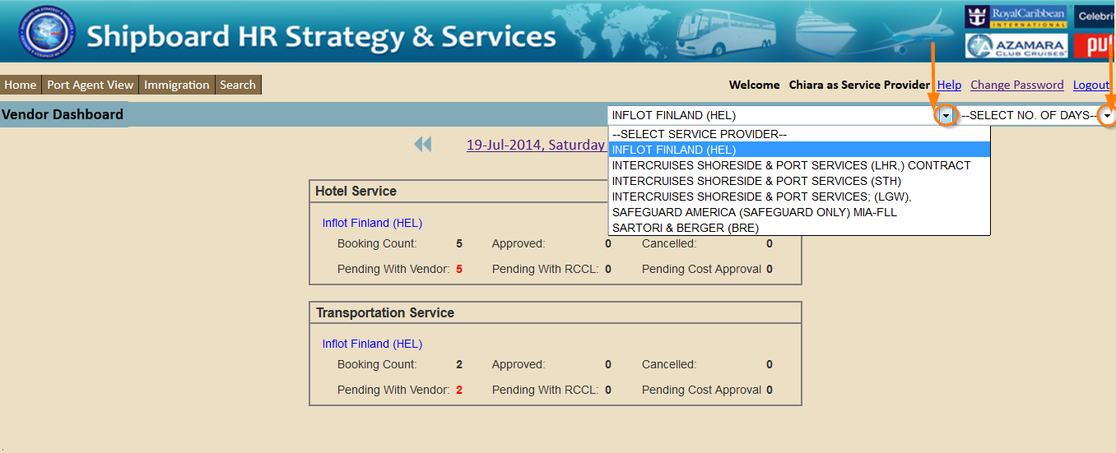

View data by Date

Step 1: Click on the date displayed at the top of the page. A calendar will appear. Or click on the arrows to go back and forth. Select a Date.
A new screen will display details of sign on and off crewmembers for that selected day.
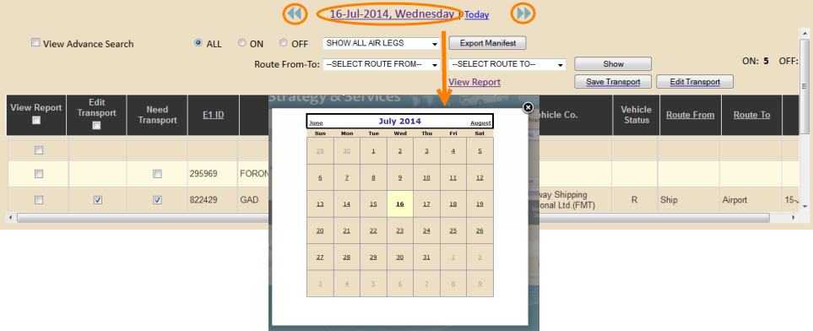

How to Confirm Manifest
The Dashboard will show a summary of count per status of each service. In the example given 5 are pending for approval with the Hotel Service and 2 are pending for approval with the Transportation Service.

Note: In this guide we will use the Hotel Service as an example but in reality you will be able to follow these steps with either service.

Step 1: Click on the Company Name (appears in blue).
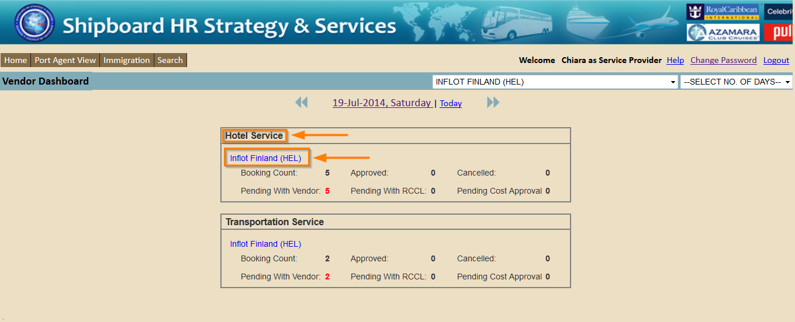
You will be redirected to a page with the list of records.
Step 2: To find a record, scroll up and down or enter in the E1 ID and click on Search.

Step 3: Once you have found the record, Select the checkbox next to the name of the request you wish to confirm.

Note: You can Select the top checkbox which will select all crewmembers currently in the list or multiple in the list.

Remember: Always pay attention to the check-in date as this may vary.

Step 4: Click on Confirm.
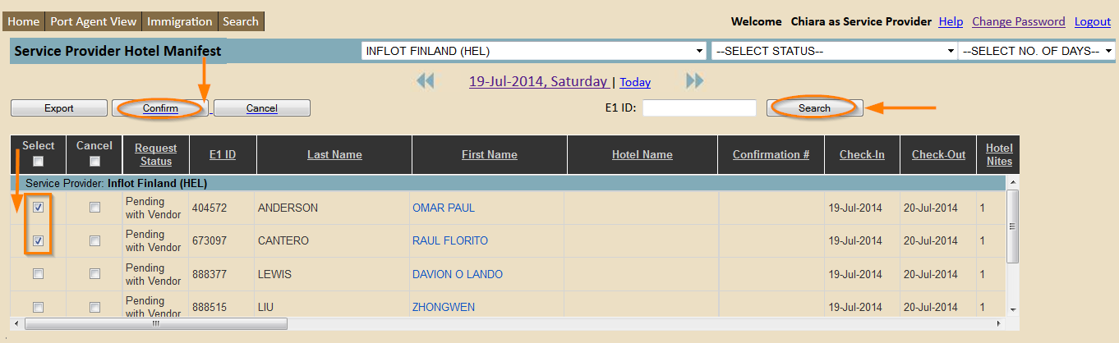
A pop up with the Confirm/Cancel Request form will appear.
Step 5: Fill in the correct information and click Confirm.
Note: All fields must be filled in correctly.

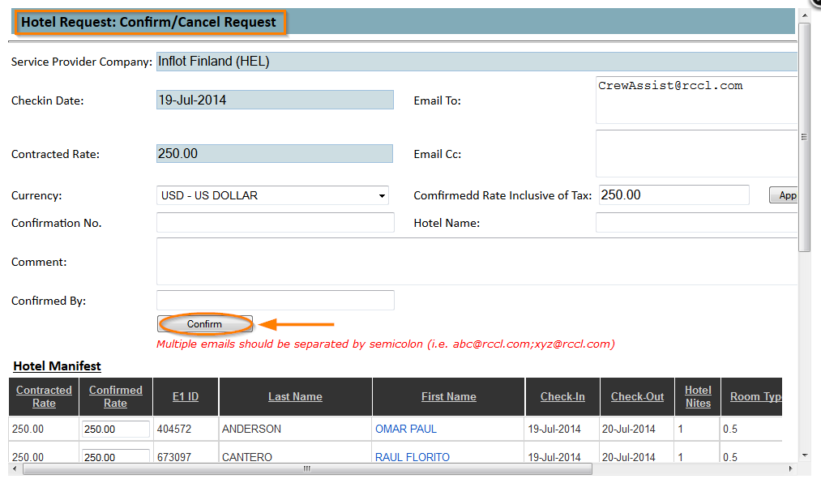
A pop up with the amount of records being confirmed will appear.

Step 6: Click on OK if you wish to continue, click on Cancel if you wish to cancel the request.

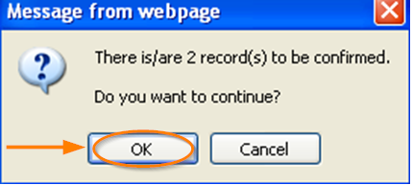

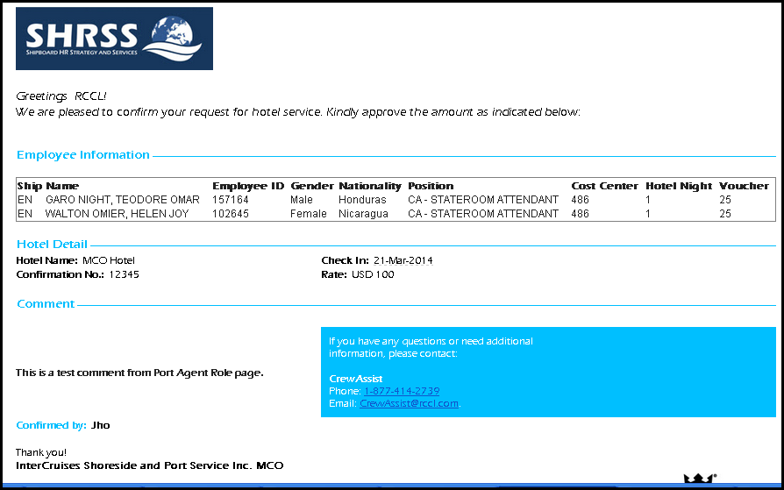
The recipient will receive the following email with the confirmation.

On the Hotel Dashboard the updated status count will appear. The request needs to go through two different approvals. First the request needs to be approved by the Vendor and then RCCL needs to approve it. Once RCCL approves it the cost is automatically approved. The status updates will appear on the Hotel Dashboard.
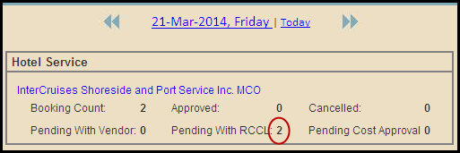

How to Cancel Manifest

The Dashboard will show a summary of count per status of each service. In the example given 5 are pending for approval with the Hotel Service and 2 are pending for approval with the Transportation Service.

Note: In this guide we will use the Hotel Service as an example but in reality you will be able to follow these steps with either service.

Step 1: Click on the Company Name (appears in blue).

You will be redirected to a page with the list of records.
Step 2: To find a record, scroll up and down or enter in the E1 ID and click on Search.

Step 3: Once you have found the record, Select the Cancel checkbox next to the name of the request you wish to cancel.

Step 4: Click on Cancel.

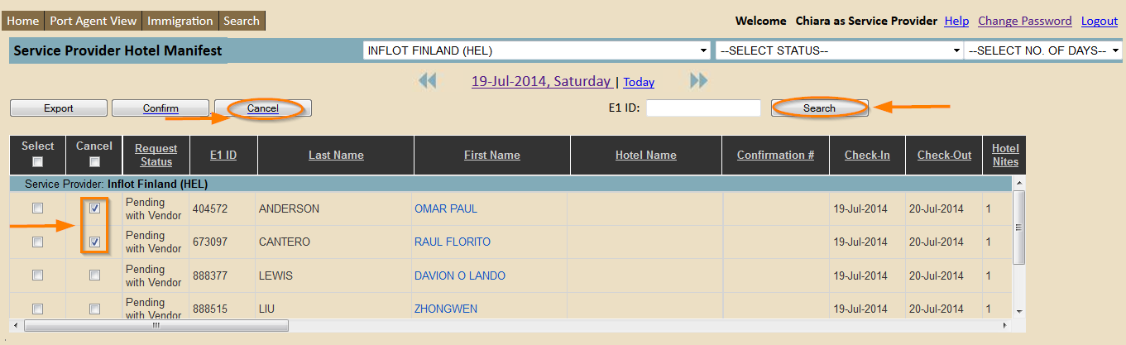

A pop up with the Confirm/Cancel Request Form will appear.

Step 5: Fill in the correct information and click Cancel.
Note: All fields must be filled in correctly. Please fill in a comment as to why this record is being canceled.

Step 6: Click Cancel.

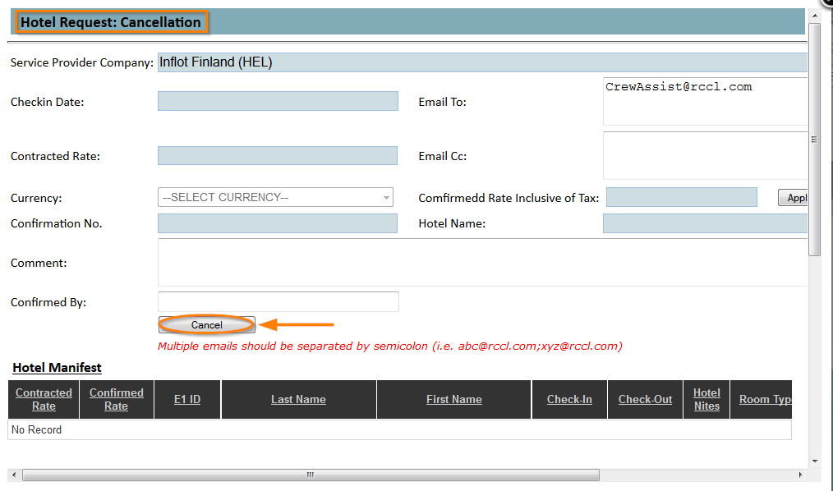
A pop up with the amount of records being canceled will appear.

Step 5: Click on OK if you wish to continue, click on Cancel if you wish to cancel the request.

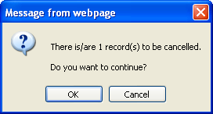

Note: Record will be deleted from the list if the Service Provider canceled it. If record was canceled by RCCL, the Service Provider will be asked to confirm notification of the cancelation.

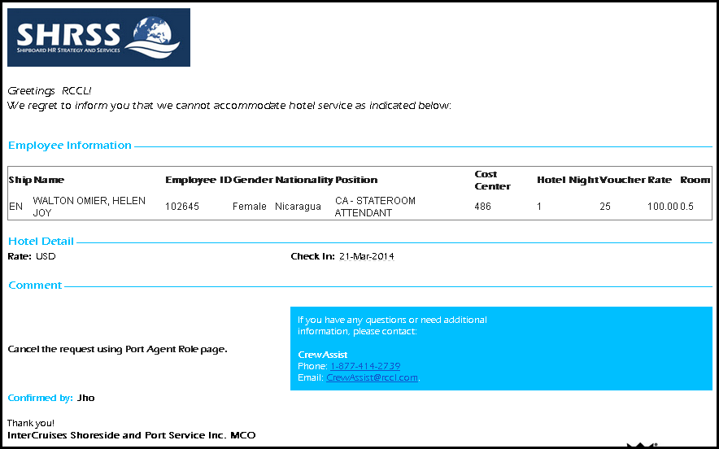
The following Email will be sent to recipient to notify them of the cancelation.

The updated status count will appear on the Dashboard.

Service Provider Confirmation

The following are scenarios that will default the record as canceled and will need Service Providers confirmation:
- If the confirmed record’s check-in date or vendor has changed.
- If the RCCL users (Hotel Specialist, Crew Assist, etc.) canceled the request.

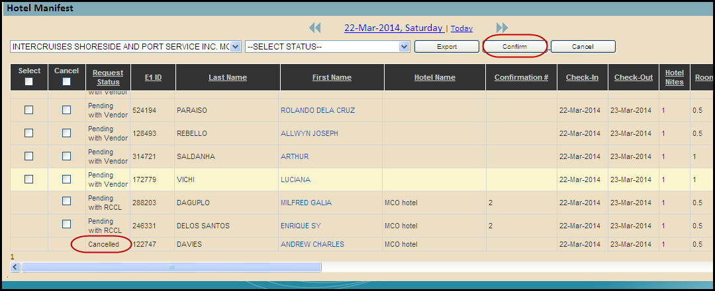
To confirm Canceled records, Service Provider needs to click Confirm record.

Note: Email will not include this record since it is already canceled and not a new canceled record.

Records that have been approved by RCCL will show on the Dashboard and in the list of records. The Vendor will be ready to provide services.
